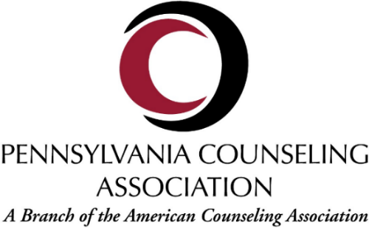
EIN: 23-7388393

Conference Sponsorship and Exhibitor Application

Do to the fully virtual nature of our conference this year, we will only be offering digital sponsorship opportunities. These will be in the form of three tiered options, as provided below.

Gold Tier - $500  Whova & Social Media combined | Silver Tier - $350  Whova Banner | Bronze Tier - $250  Social Media
Your logo, along with a link to your website, will be posted and cycling on the official conference Whova app banners. Your logo will also appear, along with other sponsors, in a pinned post on all PCA social media channels. Both of these will remain active until the close of the virtual conference on Nov. 3rd 2020 | Your logo, along with a link to your website, will be posted and cycling on the official conference Whova app banners. The banners will remain cycling until the close of the virtual conference on Nov. 3rd 2020 | Your logo will be featured on a social media post among other sponsors that will remain pinned to the top of PCA’s social media channels until the close of the virtual conference on Nov. 3rd 2020
Check Here: | Check Here: | Check Here:

Organization Name:_________________________________

Organization Address:__________________________________________________

Organization Contact Person: ___________________________________________

Phone number: __________________ Email: _______________
Conference Forms and any questions may be emailed to: pcamarketingdirector@gmail.com
Sponsor Information and receipt will be emailed to the identified contact person
Payment: Checks made payable to PCA and sent to PCA Treasurer PO Box444 Brookville, PA 15825.
For credit card payments initial here_____ and the PCA Treasurer will invoice you.

Payment must be arranged within 1 week of application submission, or at minimum prior to Thursday October 1, 2020

All logos must be emailed as an attached .jpg or .png file when your sponsorship application is emailed to Marketing and PR Director. If you wish to link your webpage on the Whova banner, your preferred URL should also be provided.

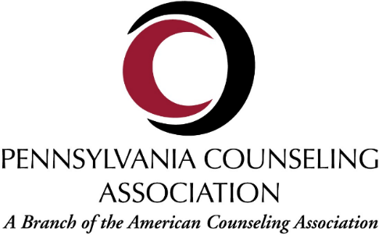

Rules and Regulations

Conduct and Restrictions: Pennsylvania Counseling Association (PCA) reserves the right to restrict and/or terminate all exhibits which, because of sound, odor, food, drink or other objectionable features (including those that run counter to the ACA Code of Ethics), interfere with the orderly procedure of the conference. PCA also reserves the right to prohibit any display or procedure which in its judgement runs counter to the general character of the meeting. Products being promoted that do not meet the ethical standards of the counseling profession will not be accepted for display.

Exhibitors may not host a function in conjunction with Pennsylvania Counseling Association’s Conference without the written consent of PCA.

The exhibitor shall, during the conference, use for exhibit, display or related purposes, only the space which has been contracted. No exhibitor will conduct a seminar or presentation in our contracted hotel and conference center from October 2-4, 2020.

Improper conduct (as the term is construed by the PCA and/or our contracted hotel and conference center, to include but not be limited to the representation of a product or service without the purchase of exhibit space, or the presence of any person associated with a commercial endeavor within the exhibit area who is not affiliated with a paid-in-full exhibitor) will not be permitted and can result in the termination of the exhibitor’s ability to display at the conference now or in the future. In the event termination does occur the exhibitor shall not be entitled to any refund of amounts paid to PCA.

Companies sponsoring prize drawings in conjunction with the conference must prominently display any limitations on registering for or accepting the prize.

The rights and obligations set forth herein apply as well to the conduct of agents and employees of the exhibitor and any property used by such companies in the installation and operation of exhibits.

The decision of PCA as to what acts constitute a breach of the above conditions shall be final and any exhibitor shall be subject to eviction without refund if it is judged to be in violation of the aforementioned conditions.

Space: The exhibitor agrees that the exhibit will be confined to the area of the space contracted and that subletting or showing products other than those manufactured or represented by the exhibitor is strictly prohibited. The exhibitor also agrees not to display noisy electronic devices, sound equipment or other devices that interfere with other exhibits. The playing of live or recorded music in an exhibit space is prohibited.
Care of Space: The exhibitor agrees not to deface, injure, or mar any surface of the hotel or conference center or any of the furniture or fixtures contained therein and/or any of the property placed therein by the PCA. The exhibitor shall be liable to PCA and the hotel and conference center for any damage to the hotel or any of the furniture or fixtures contained therein or any of the property placed therein by PCA which shall occur by reason of the commissions or omissions of any exhibitor and/or its agents or employees. All materials used in an exhibit must conform to the requirements of the fire department.

Liability, Security and Insurance: All exhibits and respective contents are displayed at the exhibitor’s risk. The exhibit area is in a public space of the hotel and conference center and will not be secure when the exhibit hours conclude. PCA assumes no responsibility for the personal property of their officers, agents, or employees. The exhibitor assumes entire responsibility and hereby agrees to protect, indemnify, defend and save harmless PCA, the contracted hotel and convention center, its owner and operator and their affiliated and subsidiary companies and their respective partners, directors, officers and employees and agents (the “indemnities”) against all claims, losses or damages to persons or property, governmental charges or fines and attorney’s fees arising out or caused by the exhibition’s installation, removal, maintenance or occupancy or use of the exhibition premises or part thereof, excluding only any liability caused by the sole negligence of the indemnities.
In addition, the exhibitor acknowledges that PCA, the hotel and conference center, and any of the other indemnities do not maintain insurance covering the exhibitor’s property and that it is the sole responsibility of the exhibitor to maintain insurance.

Payment: Contracts must be accompanied by payment in full or paid upon receipt of a credit card invoice. If any remaining balance of the full remittance of the contract has not been received by PCA by the Cancellation date of September 28, 2020 PCA reserves the right to cancel this contract without liability. In such an event, PCA shall retain the amount paid by the exhibitor as a forfeited deposit. Any exhibitor with a remaining balance by the start of the conference October 2, 2020, will not be allowed to set up until full payment has been remitted in the form of cash, certified check or money order.

Interpretations of Above Rules and Regulations: Above stated conditions are considered a part of this contract. PCA reserves the right to interpret them as well as make decisions on all points the rules and regulations do not cover. Decisions of the Pennsylvania Counseling Association are final.

