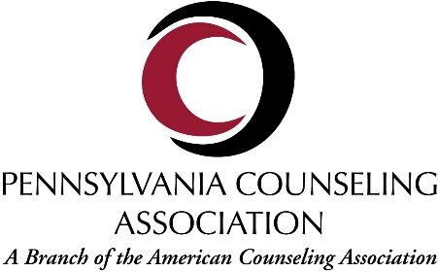
Journal of the Pennsylvania Counseling Association (JPCA) Author Submission Requirements

- Manuscripts should not exceed 30 pages, including references.
- Manuscripts should be typewritten, double-spaced (including references and extensive quotations) with 1” margins on all sides.
- Title Page: Identify the title page with a running head. The title page should include title (not more than 80 characters), author, affiliation, and an author’s note with contact information. Author’s note should be formatted exactly as it appears in this example:
Author Name, Department of _____________________, University Name [or Company affiliation]. Correspondence concerning this article should be addressed to Author Name, Department of ____________, University, Street address, City, State, zip code (e-mail: xxxxx@xxxx.edu).
- Abstract: Begin the abstract on a new page and identify the abstract page with the running head and the number 2 typed in the upper right-hand header of the page. The abstract should not exceed 75 words.
- Keywords: Keywords should follow the abstract on page 2 and are limited to 5 words.
- Text: Begin the text on a page 3 and identify the text page with the running head and page number 3 typed in the upper right-hand header of the page. Type the title of the article centered at the top of the page and then type the text. Each subsequent page of the text should carry the running head and page number.
- Tables and Figures: No more than 3 tables and 2 figures with each manuscript will be accepted. Do not embed tables or figures within the body of the manuscript. Each table or figure should be placed on a separate page following the reference list
- References: References should follow the style detailed in the APA Publication Manual. Check all references for completeness, including the year, volume number, and pages for journal citations. Please be sure to include DOI numbers as necessary. Make sure that all references mentioned in the text are listed in the reference section and vice versa and that the spelling of author names and years are consistent.
- Footnotes or endnotes: Do not use. Please incorporate any information within the body of the manuscript.
- Other: Authors must also carefully follow APA Publication Manual guidelines for nondiscriminatory language regarding gender, sexual orientation, racial and ethnic identity, disabilities, and age. In addition, the terms counseling, counselor, and client are preferred, rather than their many synonyms.
- In addition to the specific requirements of the JPCA, authors will adhere to all requirements of the Publication Manual of the American Psychological Association (7th ed.).
- An electronic copy of the manuscript should be e-mailed to the editor: Dr. Holly Branthoover (pcajournal@gmail.com).

The Journal of the Pennsylvania Counseling Association (ISSN 1523-987X) is a biannual publication for professional counselors. It is an official, refereed branch journal of the American Counseling Association, Inc. © 2022 by the Journal of the Pennsylvania Counseling Association. All rights reserved.

