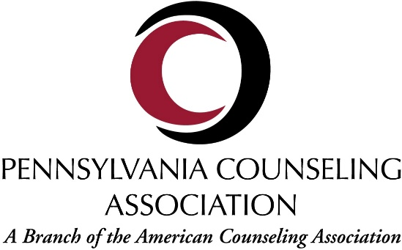



Frequently Asked Questions about the New Collaborative
Relationship between the Pennsylvania Counseling Association (PCA)
and the Pennsylvania School Counselor Association (PSCA)

1. What is the new relationship between PCA and PSCA?
PSCA is now a completely independent organization and is no longer a division of the Pennsylvania Counseling Association. This new collaborative relationship between the two associations parallels the transitions made by our national associations (ASCA and ACA, respectively).

2. Does PCA still want school counselors as members?
Absolutely! PCA is committed to being a home for all counseling specialties, including school counselors. We will continue to offer tools and resources for school counselors to learn and grow, helping them keep up with the latest evidence-based counseling strategies. With PCA, school counselors can update their skills and identify new methods to support the social and emotional wellness and mental health of children and adolescents.

3. Why did PCA and PSCA need a new relationship?
Over time, the two organizations evolved to the point where a more independent relationship makes sense. Both PCA and PSCA are thriving and a new relationship where both organizations choose to collaborate when appropriate, but otherwise are independent, supports continued growth on both sides.

4. Who started this process?
Neither organization “started” this. The new relationship parallels the transitions made at the national level by the American Counseling Association and the American School Counseling Association. It is part of a natural evolution in the relationship, and in many ways formalizes the current status of our relationship, which was established over many years.

5. Will PSCA continue to have a representative on the PCA Executive Committee?
No. Because PSCA is no longer a PCA division, they do not have a seat on the PCA Executive Committee. This does not mean that school counselors will lose representation; all PCA Executive Committee members act on behalf of the PCA mission and continue to represent all professional counselors in Pennsylvania. Both PSCA and PCA will continue to work together to ensure that school counselors have a voice in issues impacting school counseling in the Commonwealth of Pennsylvania.

6. What type of collaboration will PCA and PSCA be involved with going forward?
Both PCA and PSCA will continue to work together to support all professional counselors in Pennsylvania through government relations, legislative affairs, advocacy efforts, and professional development.

